Create an Azure Portal account:

1. Navigate into the link: portal.azure.com

It will take into the Sign in link from Microsoft.

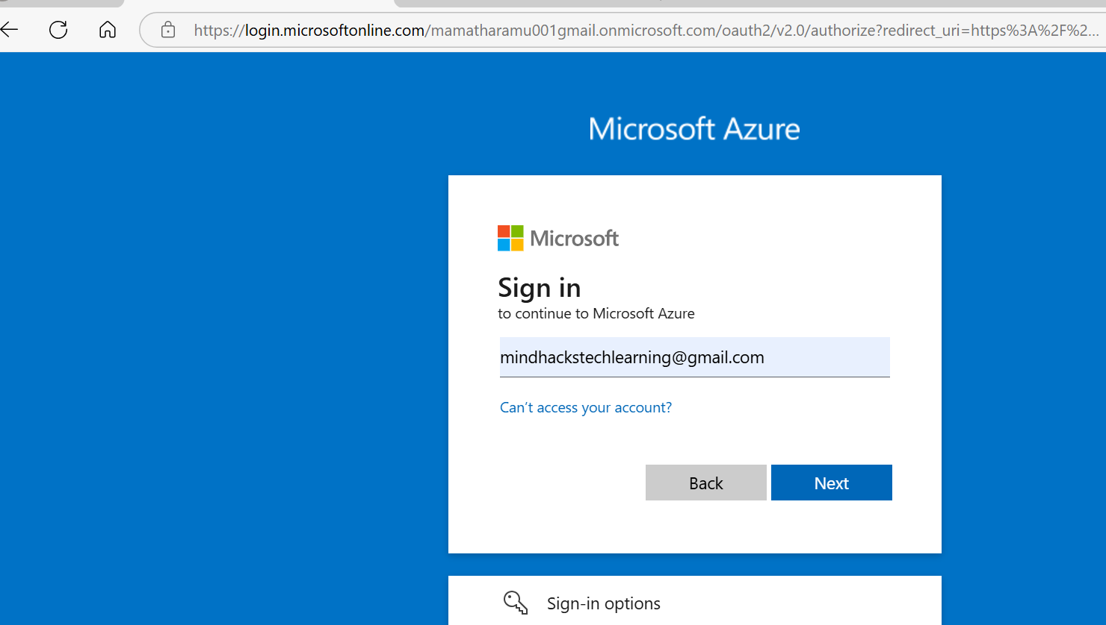

1. Enter your Microsoft account id and then click on the Next link.

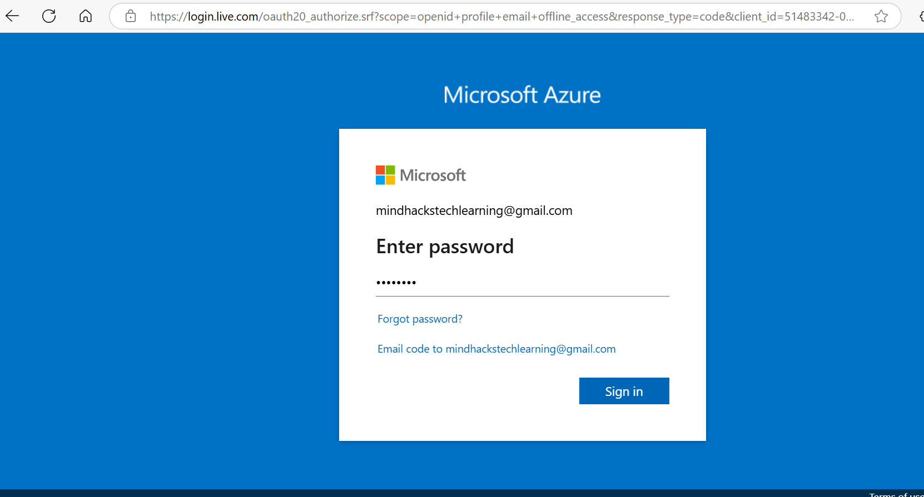

1. Enter the password and then click on Sign in button.



1. Verify the identity as your email id provided.

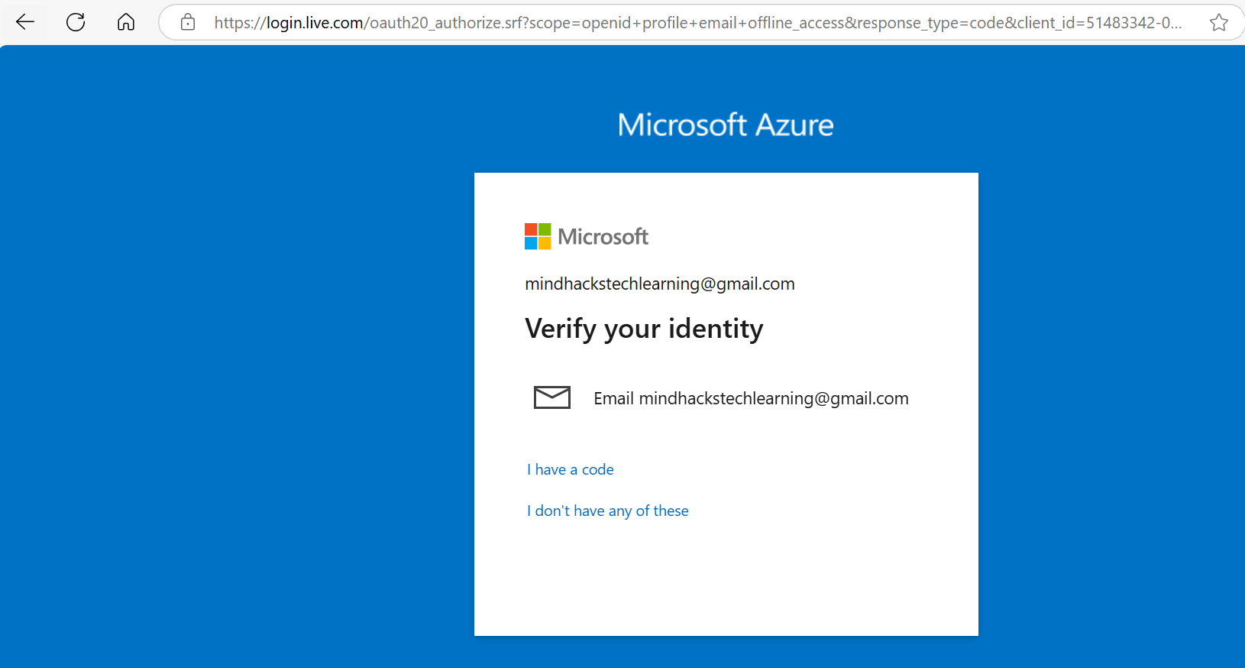

1. Enter the code that you have received into your email id and then click on verify button.

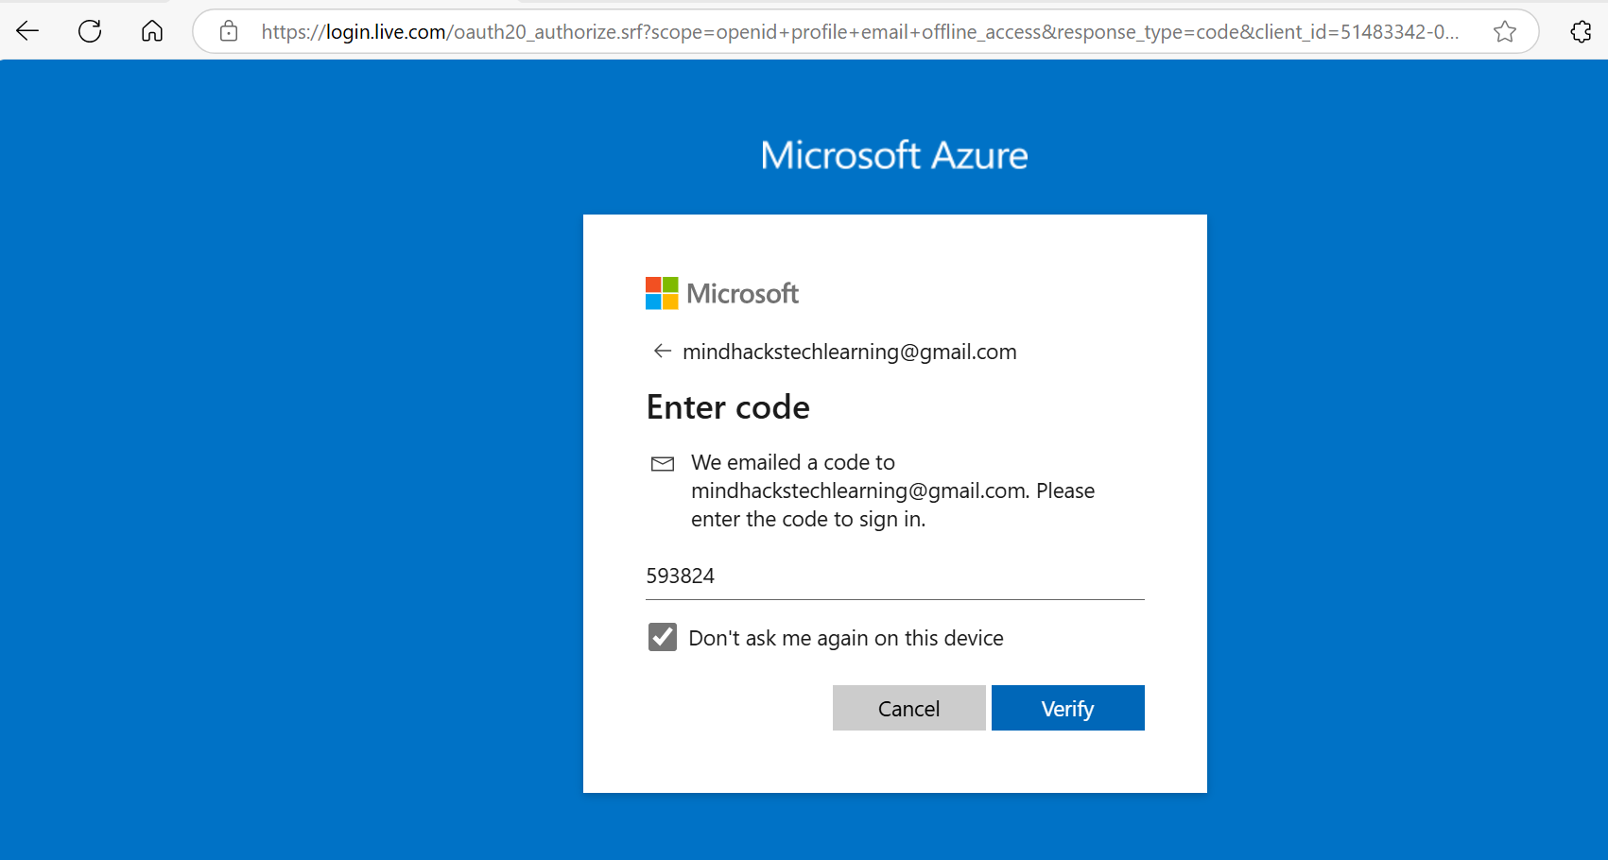

1. We will get an access into the Azure Portal account.

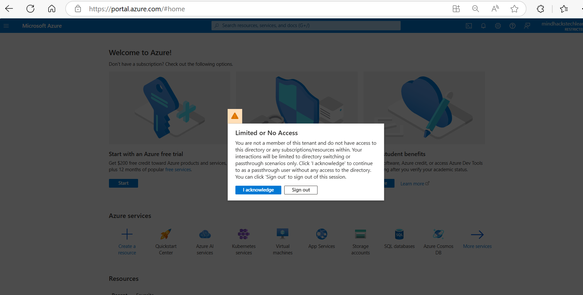

1. Click on the “I acknowledge” button on the window and then continue to use the azure portal services.

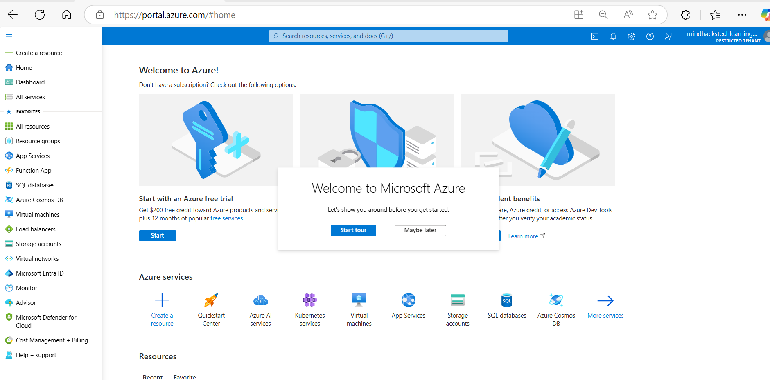

This will not activate the default directory, to activate the default directory we have to signup using the Create Your Azure Free Account link.

1. Signup using the below link:

[Create Your Azure Free Account Or Pay As You Go | Microsoft Azure](https://azure.microsoft.com/en-us/pricing/purchase-options/azure-account?icid=azurefreeaccount)

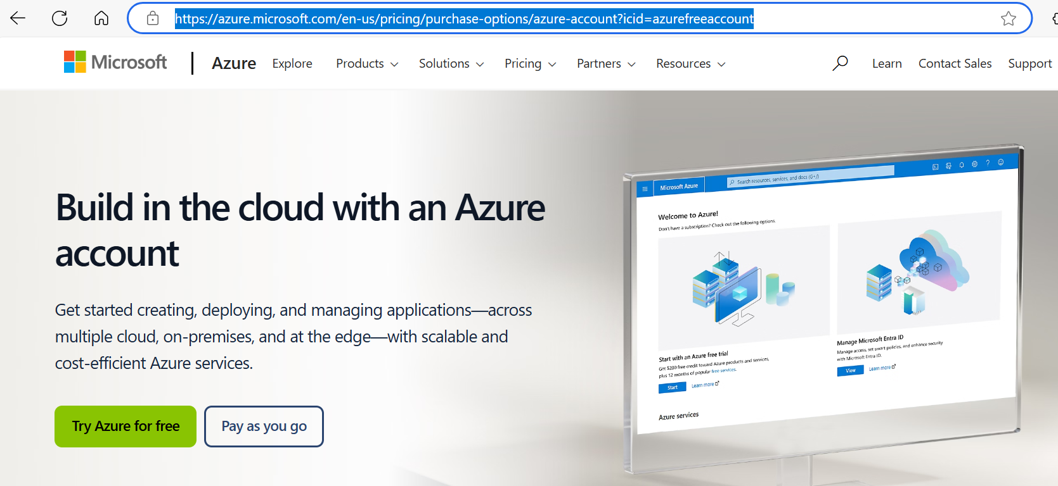

Once the authentication is successful, we can login to the portal with default directory.

